|  |  |  |  |  |  |
| --- | --- | --- | --- | --- | --- |
| Date | 24-Nov-22 | | | Tester Name | Janette Paus |
| Environment | Penfax - Test 2 | | | Login used |  |
| Operating System | Windows | Version: 21H1 | Update Number: | | |
| Software Used | Edge | Version: 107.0.1418.56 | Update Number: | | |
| Not Applicable | Version: | Update Number: | | |
| Application Release version | R22.4.1 | | | | |
| Test Case Title | E16.31 | | | | |
| Test Type | Regression | | | | |
| Test Scenario | Process VPB lump sum payment via wire transfer | | | | |
| Expected Results | Wire transfer will process correctly | | | | |
| Pass/Fail | Pass | | | JIRA# | N/A |

Search for any Active VPB member

Open that member

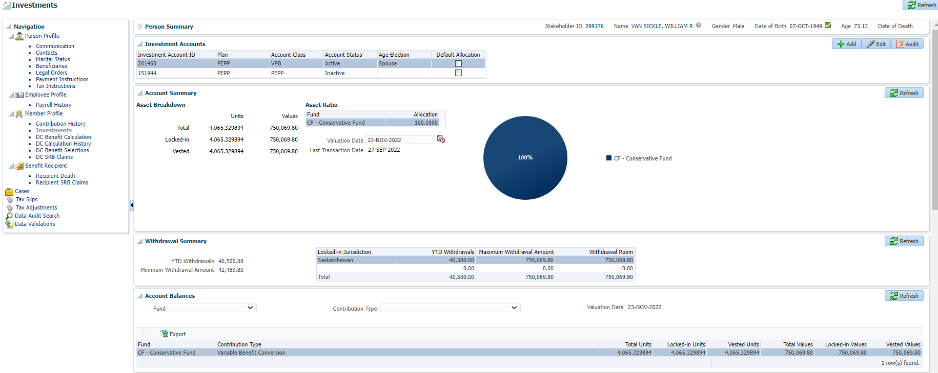

Add VPB Lumpsum withdrawal for any $ amount and click Save

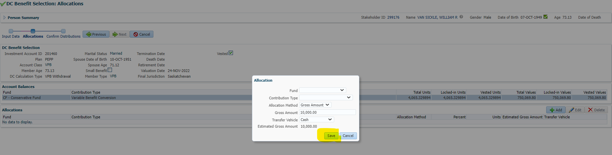

Click Next

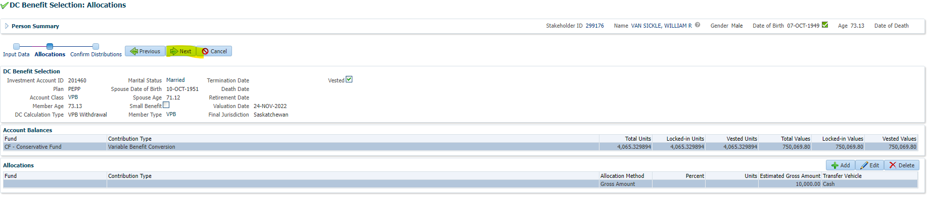

Uncheck Automatic Approval to add wire transfer fee the next day

Add Payment and Tax Instruction

Click Submit for Approval

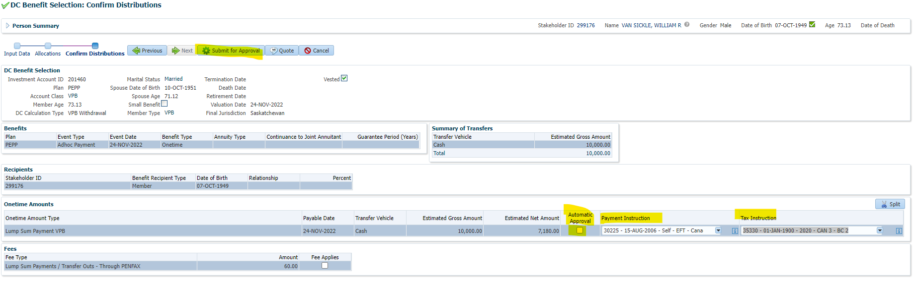

Click Approve

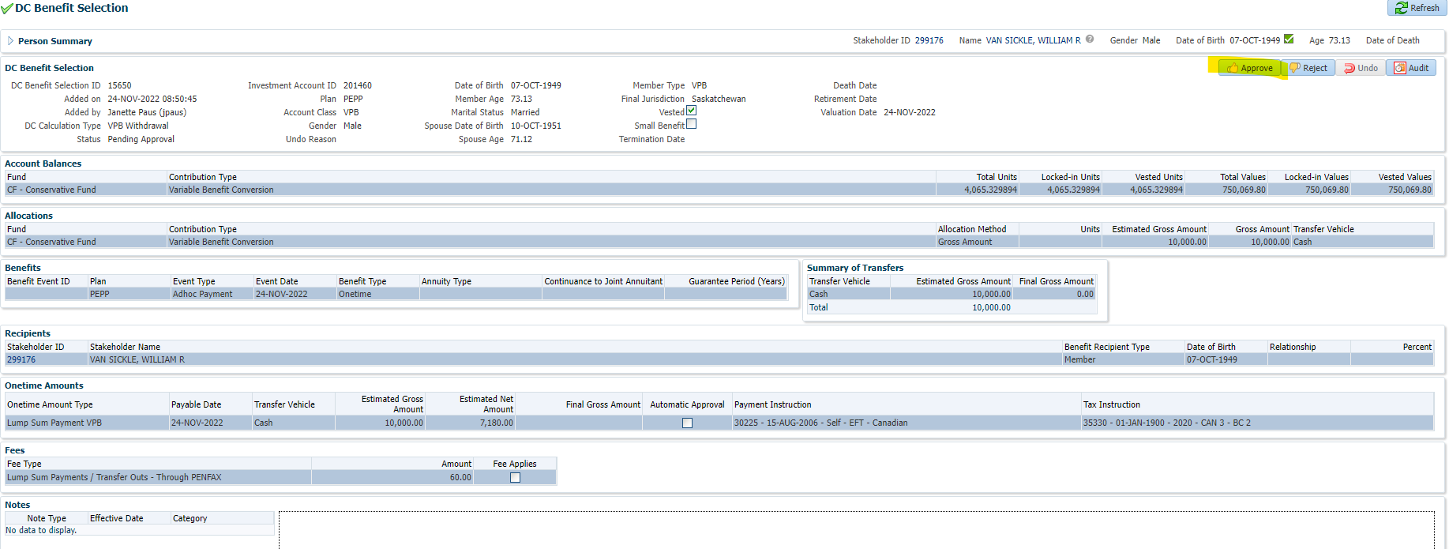

After PIT batch overnight

Open that member profile again

Under Investments 🡪 Account Activity unit values are displayed

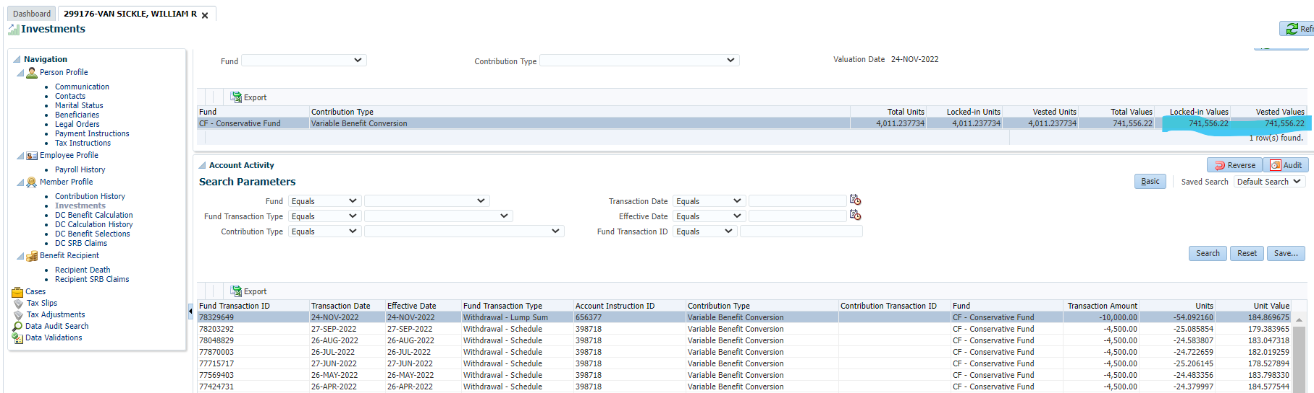

Under Benefit Recipient 🡪 Onetime Amount tab, view the new payment

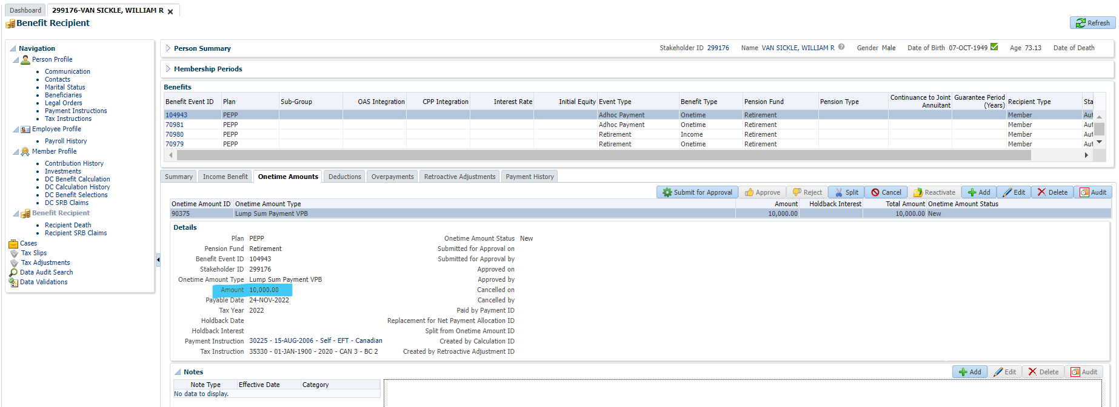

Click Deduction tab, add Wire Transfer Fee and click Save

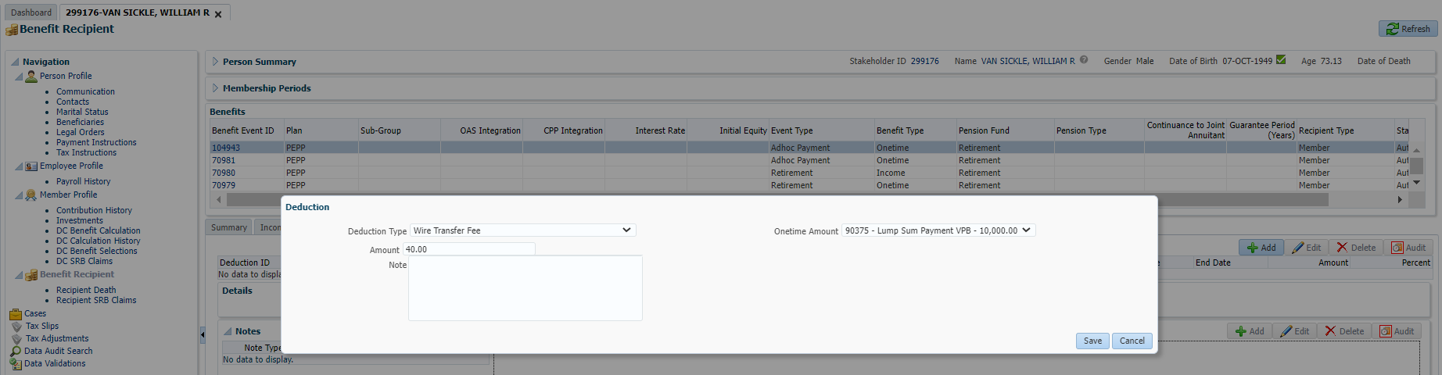

Click Onetime Amount tab and Submit for Approval to approve the wire transfer

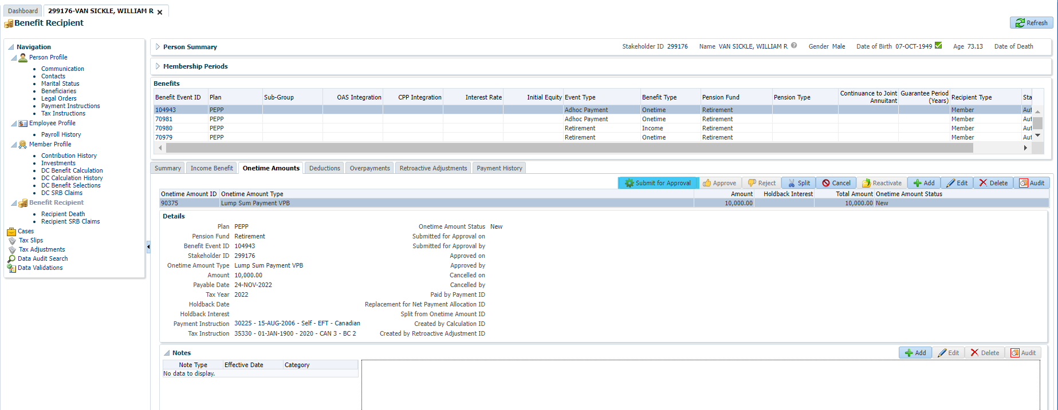

Click Approve

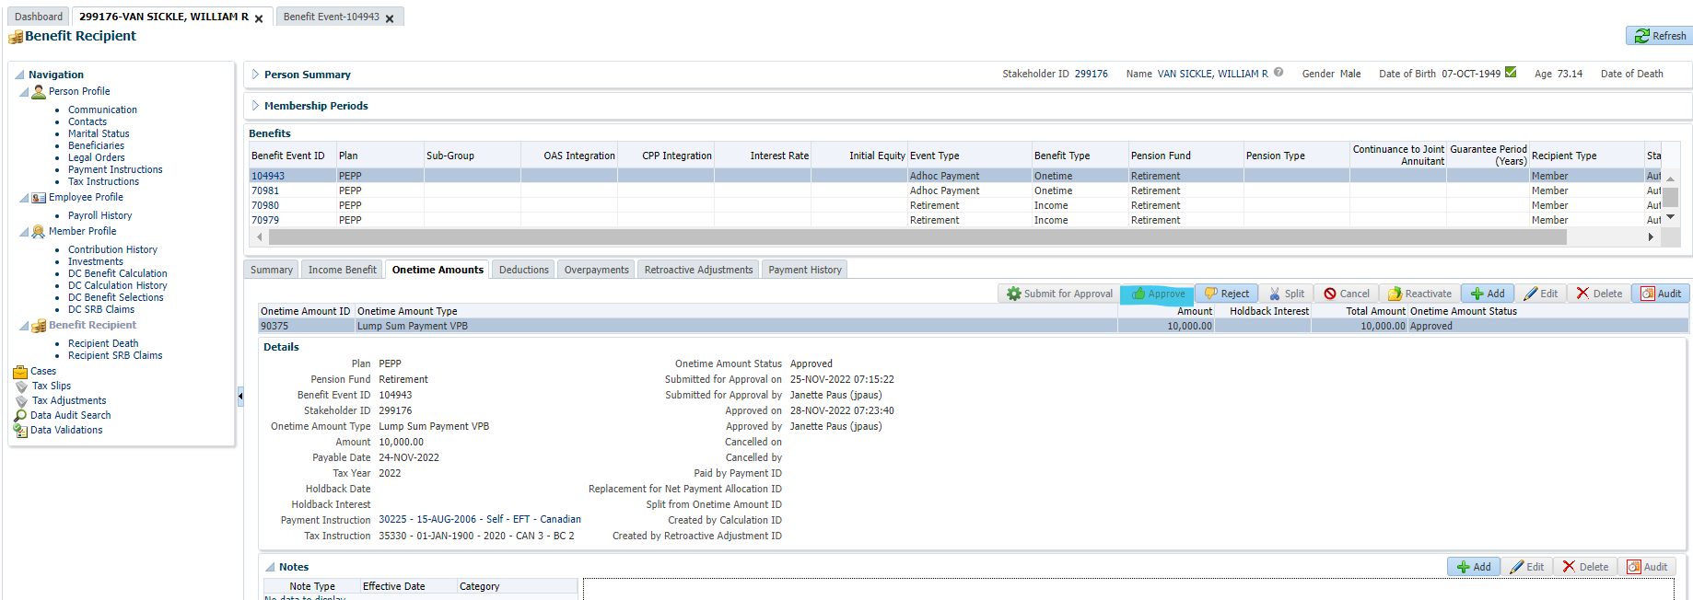

After PIT batch runs again and the payment batch is processed, the Payment ID and Taxes will be displayed under the Onetime Amount tab

